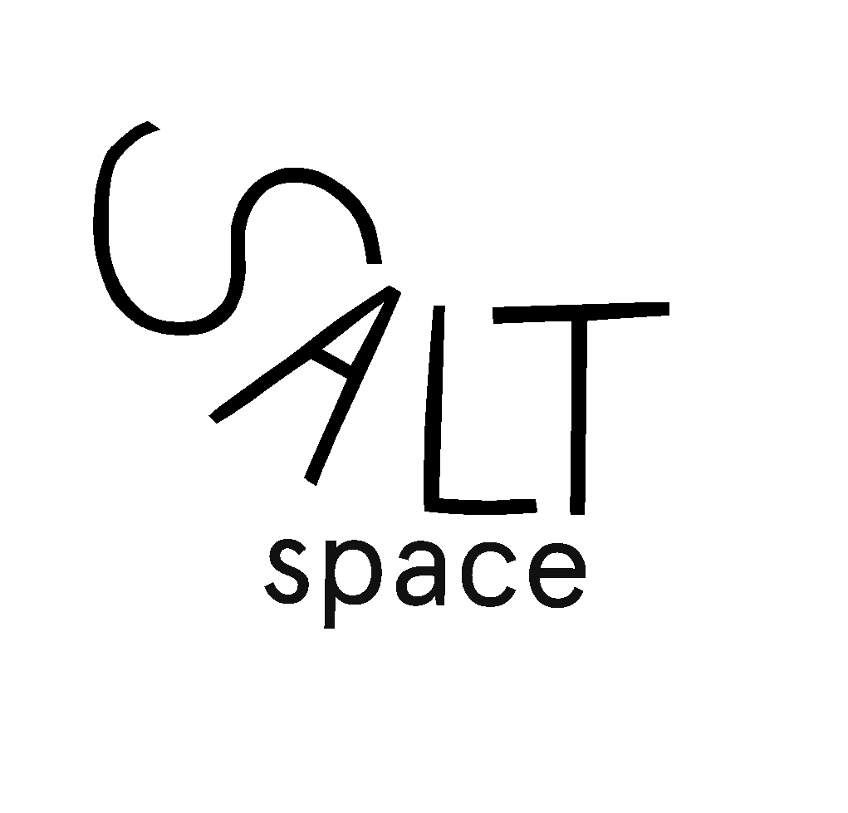
Gallery Space Exhibition/Event Proposal Form for Salt Space

The purpose of this form is to evaluate the exhibitions and events we host are relevant to the aims and values of Saltspace as they are central to all of our decisions.

These are the Saltspace aims and values:

Our Aims:
1. Providing a platform for new artists to make, exhibit and sell work with a strong support network
2. Promoting creative collaboration, skill-sharing and learning
3. Nurture an accessible and inclusive creative space
4. Meaningfully engage with our local community
5. Provide a sustainable co-op for future members
6. Cultivate honesty and transparency at all levels

Our Values:
1. Creativity and Collaboration
2. Support
3. Education and Skill-sharing
4. Accessible and Inclusive
5. Sustainable
6. Openness and Transparency

Please create a document/pdf outlining the below questions and email to saltspaceproposals@gmail.com

- Which of the Saltspace aims and values does the exhibition/event facilitate/
Address and how?

Aims:
Values:

- Name of Exhibition :
- Description of Exhibition:
- Is the event/exhibition ticketed or free? :
- If ticketed, how much will you be charging per ticket?:
- Does the event involve the sale of alcohol or preparation of food? Y/N
- Do you have any promotional graphics I.e Logo, posters, flyers we can use
- within the space and creative flyers to promote your event? :
- Website (to help us promote you) :
- Social Media pages (to help us promote you) :
- What are your requirements for the space? :
- What changes, if any, do you have in mind to make to the space? (i.e. painting
the walls.) :
- Any essential equipment?
- Any equipment you will be using in the space that you are providing yourself? :
- How many people do you estimate to attend the event?
- How many days do you require to use the Salt Gallery Space? :
- Desired date(s) for exhibition/event :
- Day(s) for setting up and painting :
- Day(s) for take down/tidy up of exhibition (We expect the space to be returned
to the exact same condition as before. Including re-painting the walls.) :
- Are you happy for us to promote your workshop/event on our website and social
media pages? :

Terms & Conditions (please read) – include a checked, signed, and dated version of this in your application document.

1. We have a non-refundable fee of £50 to host an exhibition within the SaltSpace Gallery and is donated straight back into the Co-operative to aid in its continual operation and to pay for any overhead costs in relation to the exhibition. Thereafter we charge £15 per day.
2. We currently do not have the resources to provide any media equipment, therefore any media equipment needed will have to be facilitated by the artist/s.
3. All sales of artwork must go through Saltspace and there is a 20% commission payable to Saltspace on the sale of any artwork during the exhibition.
4. The exhibition/event may not involve the sale of alcohol or the preparation of food as Saltspace does not have a license for this.
5. We expect all work to be insured by the artist/s themselves. We have Public Liability Insurance but not artists work insurance.
6. We will do our best to get volunteers for invigilation but cannot guarantee it and expect the artist/s to invigilate on any days we cannot cover.

Please tick to agree to the Terms and Conditions Above

Signed :__________________________
Date: ____________________________

Please create a document/pdf outlining all criteria/questions and email to saltspaceproposals@gmail.com

